# Git Training – Atom Editor

Created: 30 January, 2019 – Modified: 30 January, 2019

Table of Contents

Git Training - Advanced 1

Overview 1

Removing a Tracked File 1

Revert to a Previous Commit 1

Finding the SHA Key 2

Revert to a Set of Files in a Previous Commit 2

FTP Management 2

Installing 2

Setup 3

Initializing 3

Updating Files 3

Workflow 4

An Easier Way 4

Ignore Files and Folders 5

For the Repository on the Local Machine Only 5

For the Project 5

References 5

## Overview

This document will cover how use Git in Atom editor.

## Installing Atom

Atom comes with Git installed out of the box.

1. Download Atom - <https://atom.io/>
2. Run the install

## Cloning a Repository

1. Press 'cmd shift p' to open the command finder
2. Type 'clone' to find 'GitHub: Clone'  
   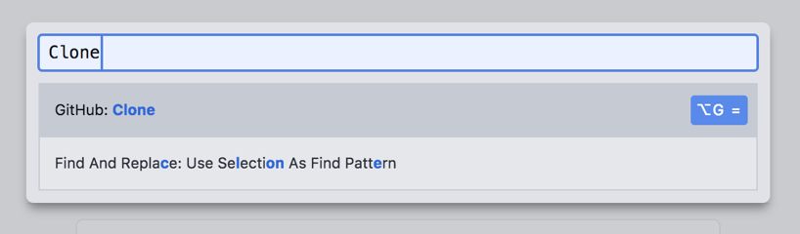
3. Enter the remote repository url
4. Enter the local directory to clone the repository into
5. Press 'Clone'  
   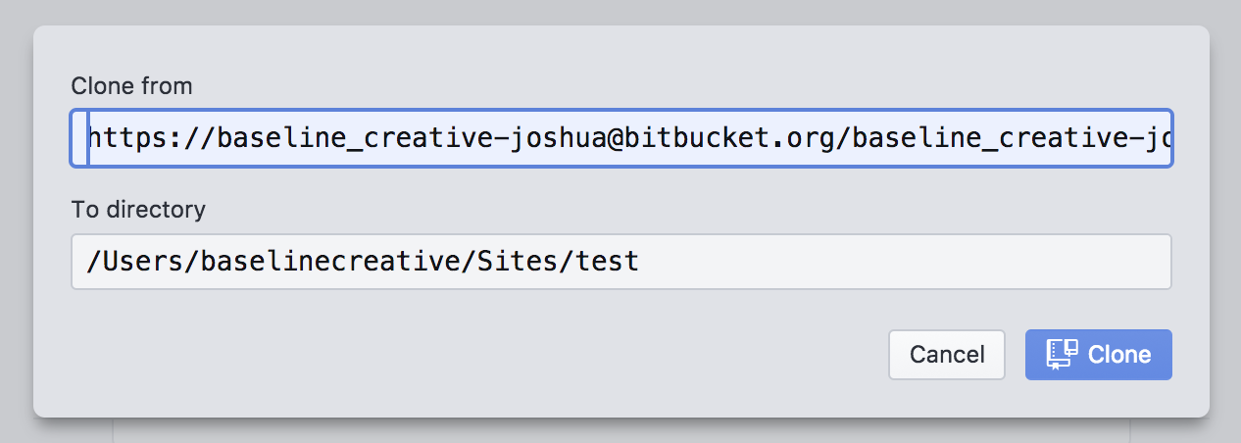

## Opening a Repository

Atom will automatically detect a Git repository when the repository is opened in Git.

1. Launch Atom
2. Go to File -> Open  
   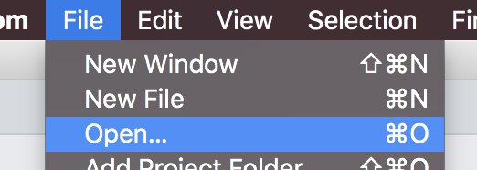
3. Select the folder containing the Git repository
4. Click 'Open'  
   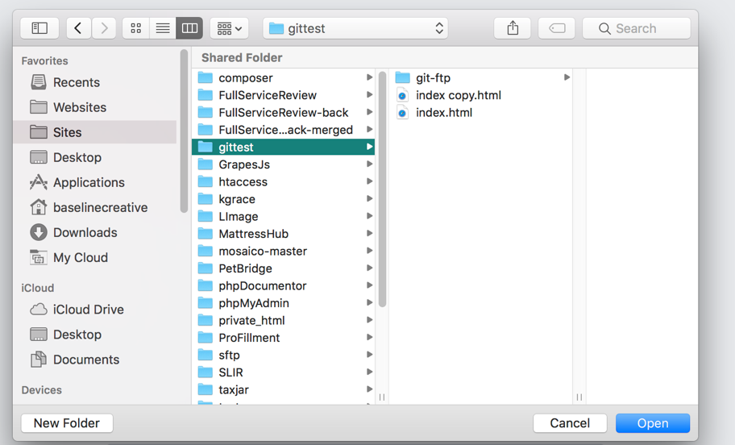

## Staging Files

Staging files prepares them for commit. In the terminal this is done using 'git add'. In Atom:

1. Click the Git icon in the bottom right corner  
   
2. Select one or more files  
   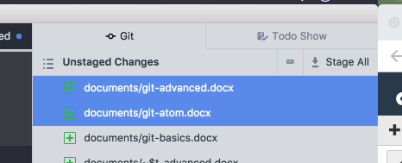
3. Press 'Enter' to stage

## Committing Files

1. Enter a message in the Commit Message box
2. Click 'Commit to master'  
   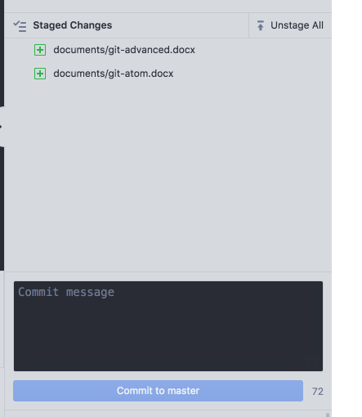

## Pushing, Pulling, and Fetching Files to and from the Remote Repository

1. Right click the 'Push' or 'Fetch icon in the bottom right of the editor
2. Select the action to perform (the last selected action is display in the footer bar  
   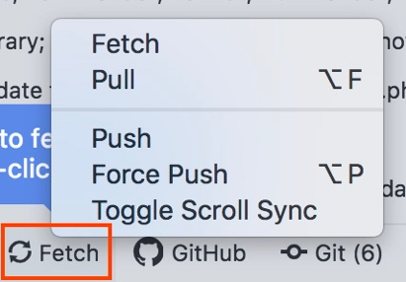

## Create a Branch

1. Click 'Master' in the bottom right of the editor
2. Click 'New Branch'  
   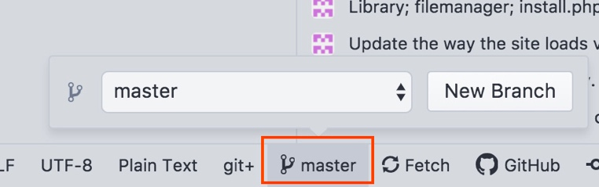
3. Enter the name of the new branch
4. Click 'New Branch' again  
   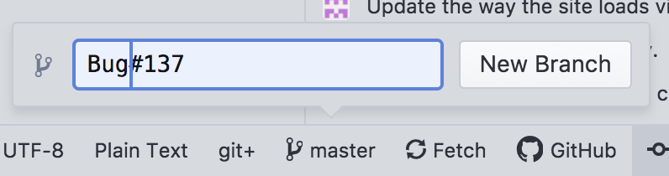

## Switch to a Branch

1. Click 'Master' in the bottom right of the editor
2. Select the branch from the dropdown menu  
   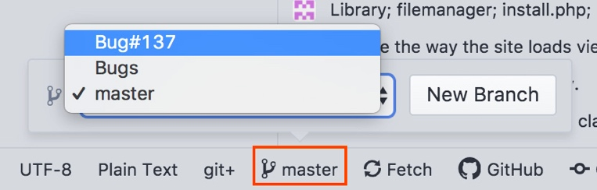

## Opening a Terminal

All other Git actions need to be performed through a terminal. A terminal can be opened directly in Atom

1. Press 'ctrl shift T' or
2. Press 'cmd shift P' to open command search
3. Type 'terminal'
4. Select 'Atom Ide Terminal: New Terminal  
   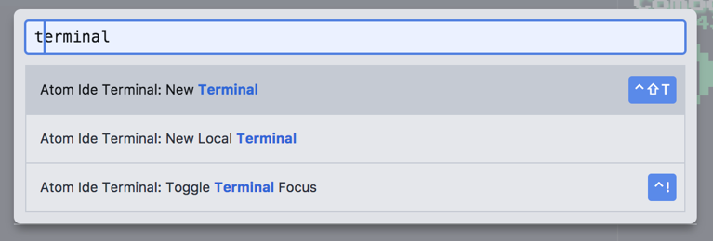

## References

* https://flight-manual.atom.io/using-atom/sections/github-package/